**Data Analytics With Tableau**

**Assignment-1**

**Name:** GUNDU PRASANTHI.

**Roll No:** 22481A0484.

**College:** Seshadri Rao Gudlavalleru Engineering College

**Visualizations:**

1. BarChart
2. PieChart
3. Stacked Bar Chart
4. LineChart
5. Bubble Char

**1.Bar Chart:**

* **Column:** Drag and drop Total to columns
* **Rows:** Drag and drop product line to Rows
* **In marks card:**
* **colors:** Drag and drop Total to colors

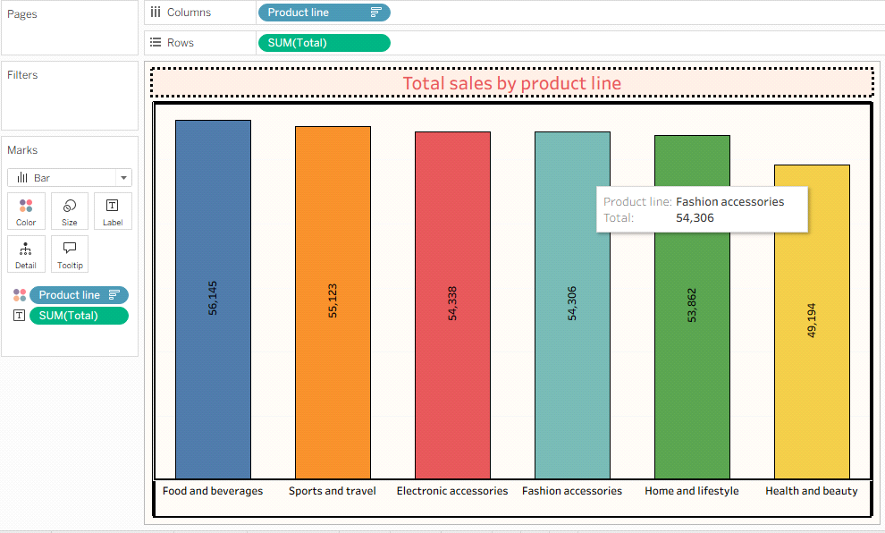

**2. Pie Chart:**

* **Column:** Drag and drop payment
* **Rows:** Drag and drop Total
* Click on **show me** panel -> click on **pie chart**
* **In marks card:**
* **Payment** ison **colors.**
* **Sum(Total)** is on **Angle.**
* **payment** and **sum(Total)** are on **Label.**(in label->click on percent of total

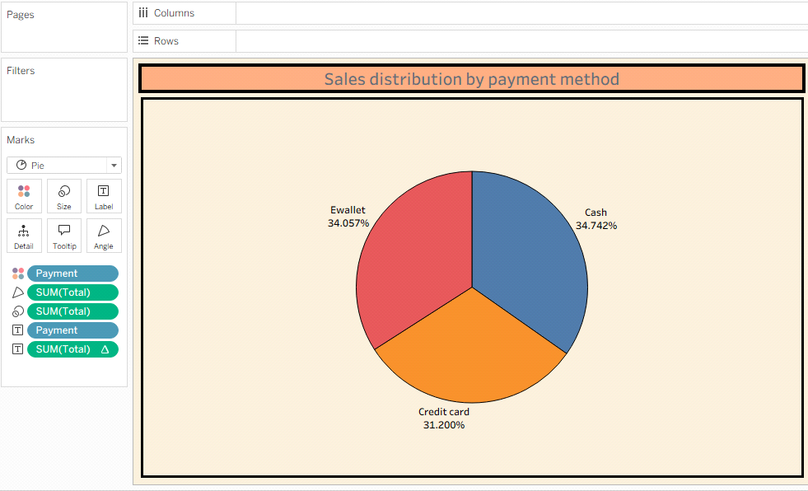

**3. Stacked Bar Chart:**

* **column:** Gender
* **Rows:** Customer type and change aggregation(measures->count)
* **In mark card: color:** Customer type

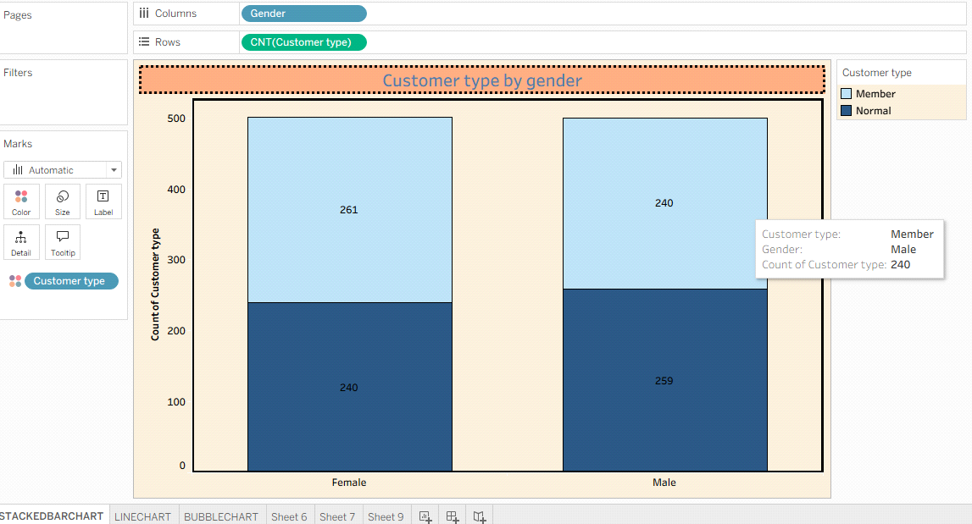

**4. Line Chart:**

* **column:** Date-> change year to Exact date
* **Rows:** Total
* **In mark card:** Sum(Total) is on Label.

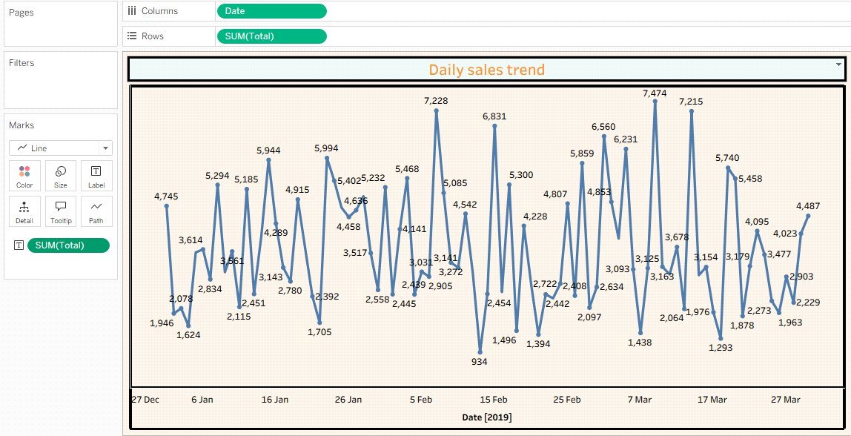

**5. Bubble Chart:**

* **column:** Quantity
* **Rows:** Sum(Total)
* **In mark card:** color and Label: product line, size: sum(Gross income)

